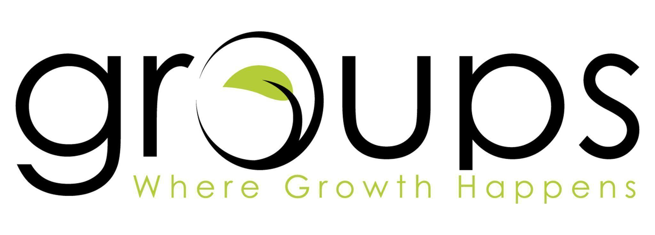

|  |
| --- |
| **Easter Eggs: Glimpses of Jesus | Week 3 | March 30, 2025** |

**Scripture: Psalm 41:9; John 13:12-30**

**Big Idea: Jesus’ betrayal set in motion the greatest act of redemption in history.**

**Questions for Connection** (*Offer these to help start the conversation)*

1. What is your favorite season and why?
2. Who has been the person you’ve trusted the most in your life? Why did you trust them?

**\*Before entering the following section, pray that Jesus would lead the discussion.\***

**Read Psalm 41:9 & John 13:12-30**

1. In Psalm 41:9, David speaks of betrayal by a close friend. What kind of emotional weight do you sense in his words? **Read all of Psalm 41.** As you read the psalm, how does David express his release from that weight?
2. Have you ever struggled to trust God’s plan when something painful or unjust happened? How did you respond? How can Jesus’ response to betrayal help us when others hurt us?
3. How does Jesus’ willingness to endure betrayal help us grasp the cost of our salvation? What parts of your life do you think you’ve kept from the full impact of that gospel truth?
4. When you think about betrayal in light of Psalm 41 or John 13, what stands out to you? Is there a place in your life right now where you feel stuck or like God’s plan has stalled? How do you move forward?
5. One of the main points from the message was, “What looks like tragedy is the beginning of redemption.” How can we focus on the hope of redemption when everything feels hopeless? Is there something the group can pray for in areas where you feel there is no hope?
6. What is something that has recently impacted you through *Live It Out*?

|  |
| --- |
| **Prayer focus: Quiet Waters, April 3-4**   * Please take time to pray for those serving at Quiet Waters. * Pray for those who are attending. * Pray lives will be changed because of what they hear from Jesus. |

**\*Make sure to spend time praying as a group before you end.\***