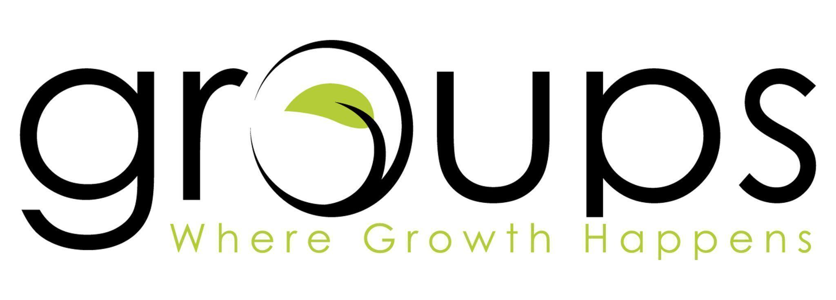

|  |
| --- |
| **Flipped: Turning the World Right-Side Up | Week 1 | April 27, 2025** |

**Scripture: Matthew 5:1-12, 7:28-8:1**

**Big Idea: Jesus flips our values right-side up.**

**Questions for Connection** (*Offer these to help start the conversation)*

1. What’s the funniest time someone told you, “Bless your heart!”?
2. What was the most nervous you’ve been speaking in front of people?

**\*Before entering the following section, pray that Jesus would lead the discussion.\***

**Read Matthew 5:1-12, 7:28-8:1**

1. How do the Beatitudes contrast to what the world would define as the good life? Which Beatitude has been most real or relevant in your life recently? Give an example of one you’ve noticed in someone else in the group.
2. How does Jesus’ definition of the good life challenge you? Have you experienced blessing in the midst of hardship or persecution for your faith? What was that experience?
3. Living as a citizen of Jesus’ Kingdom changes how we respond to conflict, stress, or injustice. Where has this been evident in your life? Are there areas where your natural response should be different?
4. What is God currently teaching you about what matters most?
5. Jesus leads us into a whole-life response. What could this look like in your workplace, friendships, or home? Where have you seen this in others?
6. As a group, ask Jesus, "Which value of your Kingdom do you want to shape more deeply in me right now—and what could be keeping me from embracing it?"

|  |
| --- |
| **Relationally Connected**  *“We are made for relationship with Jesus and other followers of Jesus.”*  What does it look like for your group to live out the values of Jesus’ Kingdom together? |

**\*Make sure to spend time praying as a group before you end.\***